**ASSIGNMENT 15.3**

**PROBLEM STATEMENT:**

1. **Explain the working of SQOOP in brief**

Sqoop is a tool designed to transfer data between Hadoop and relational database servers.

It is used to import data from relational databases such as MySQL, Oracle to Hadoop HDFS, and export from Hadoop file system to relational databases.

Sqoop Import

The import tool imports individual tables from RDBMS to HDFS. Each row in a table is treated as a record in HDFS. All records are stored as text data in text files .

Sqoop Export

The export tool exports a set of files from HDFS back to an RDBMS. The files given as input to Sqoop contain records, which are called as rows in table. Those are read and parsed into a set of records and delimited with user-specified delimiter.

1. **Import a table from Mysql to HBase table using Sqoop.**

**Step 1:**

**Firstly the tables are to be populated into the hbase**

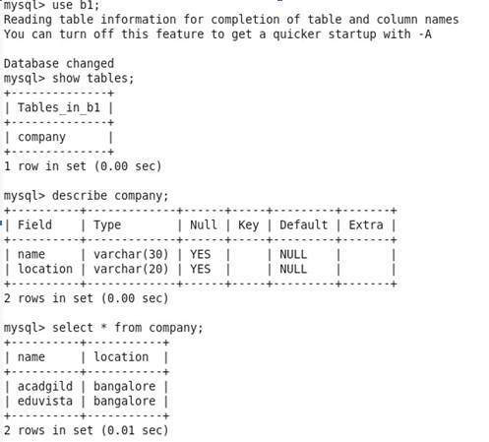

**Step 2:**

**Creation of the hbase table is done here.**



**Step 3:**

**Sqoop is now user to the transfer of the data.**

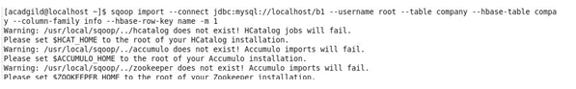

**Step 4:**

**Required output**

